**LAB 4**

**INTRODUCTION TO XILINX ISE AND Spartan 6 BOARD and implementation of MUX and DECODERS**



**Spring 2025**

Submitted by: **Mohsin Sajjad**

Registration No: **22pwsce2149**

Class Section: **A**

“On my honor, as student of University of Engineering and Technology, I have neither given nor received unauthorized assistance on this academic work.”



Student Signature: ______________

Submitted to:

**Engr. Faheem Jan**

Month Day, Year (16 03, 2025)

Department of Computer Systems Engineering

University of Engineering and Technology, Peshawar

**Objectives:**

* Introduction to FPGA
* Introuction Xilinx ISE

**Lab Task:**

**Task 01:**

Develop a program to control on Board LED using On board available switch.

**Code:**

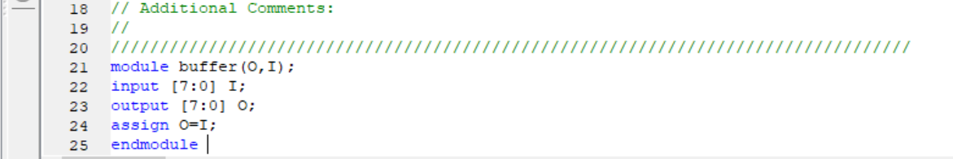

**Output:**

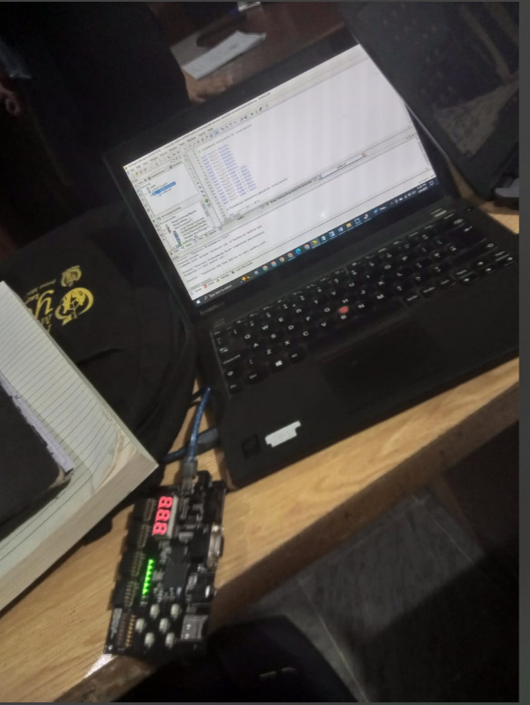

**Task 02:**

Develop a program that implements a 2x1 multiplexer on the board. Connect the inputs to switches and output to led.

**Code:**

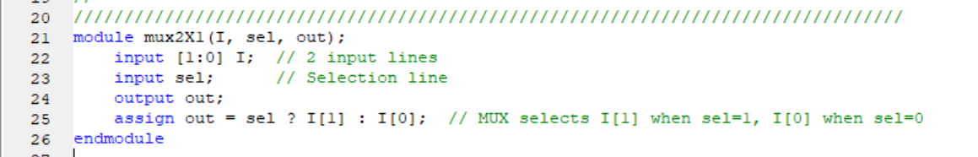

**Output:**

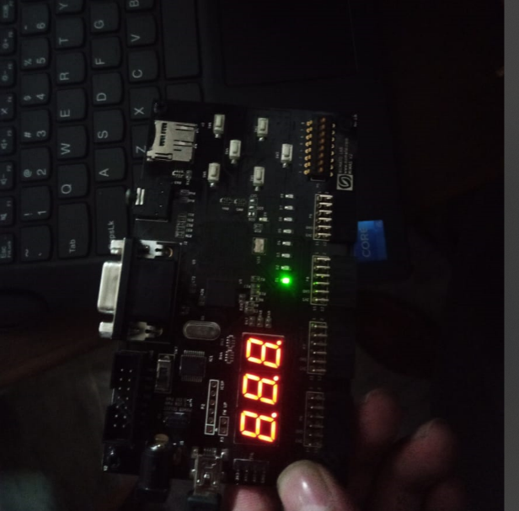

**Task 03:**

Develop a program that implements a 4x1 multiplexer on the board. Connect the inputs to switches and output to led.

**Code:**

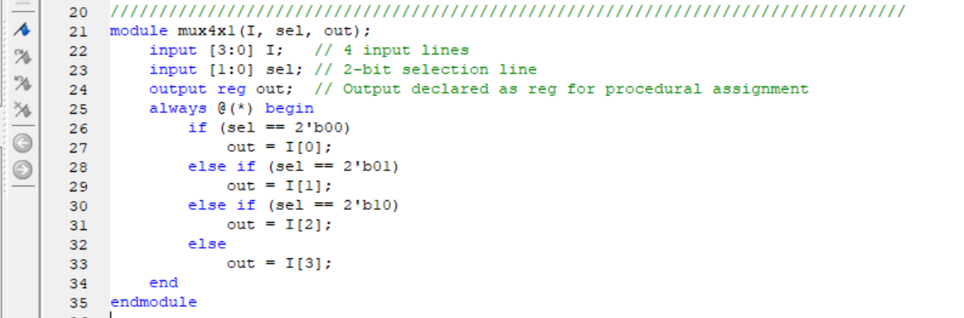

**Output:**

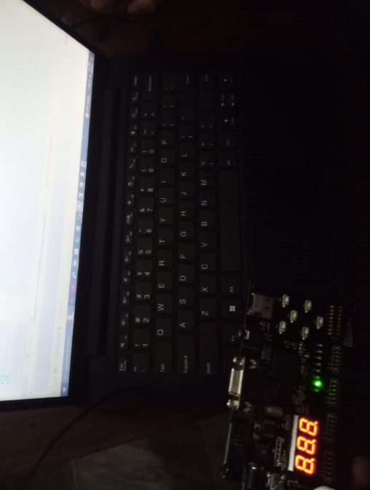

**Task 04:**

Implement 2X4 Decoder and 3x8 Decoder on the Board.

**2X4:**

**Code:**

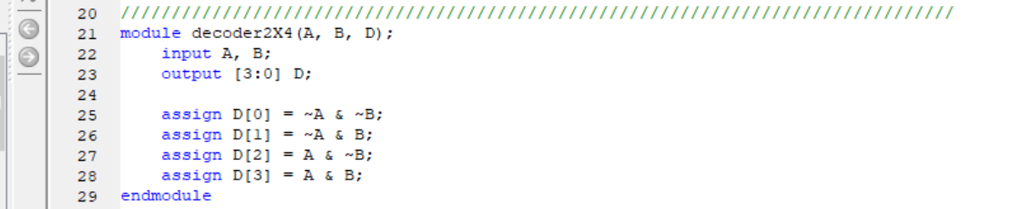

**3X8:**

**Code:**

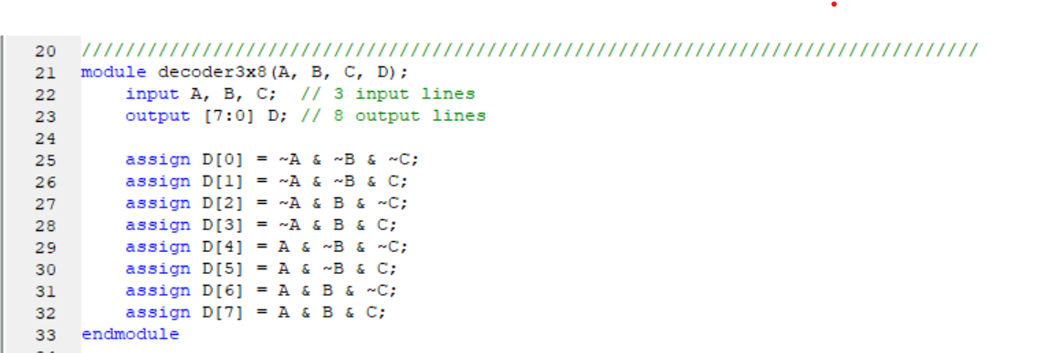

**Output:**

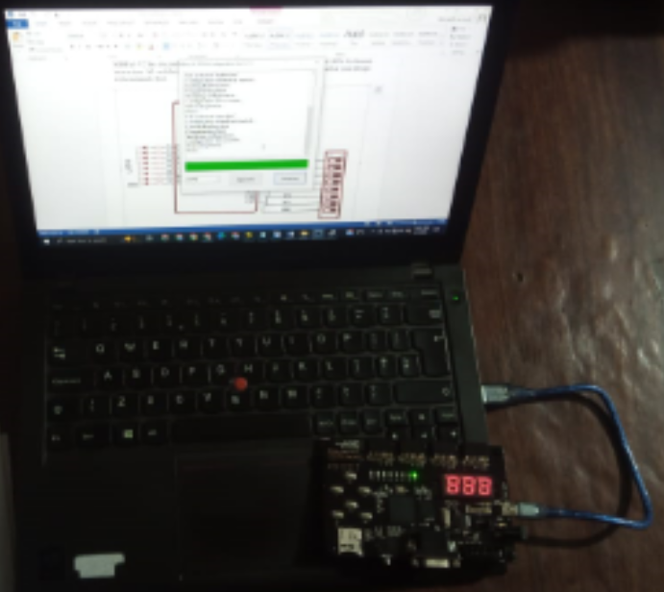

**Task 05:**

Implement NOT gate using MUX

**Code:**

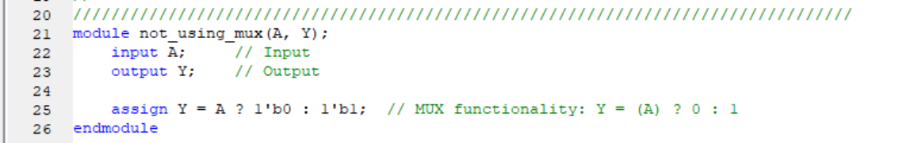

**Output on Xilinx:**

